Issue 9 – April 2023
Welcome
Welcome to the West Yorkshire Adversity, Trauma and Resilience monthly bulletin which provides updates on the programme and updates from each ‘place’ on the current work being undertaken and the current workstreams.
Adversity, Trauma & Resilience Programme – Our Ambition
Working together with people with lived experience and colleagues across all sectors, organisations to ensure that West Yorkshire is a trauma informed and responsive system by 2030.
Launch of the new ATR Academy Website
If you haven’t already registered for our website, please use this link: West Yorkshire Health and Care Partnership and West Yorkshire Violence Reduction Unit (westyorkshiretraumainformed.co.uk)
We would also welcome any resources/content/links that you may have to add to the website

Knowledge Exchange 2023 – Tuesday 21, Wednesday 22 and Thursday 23 March
We recently held our third annual Adversity, Trauma and Resilience Knowledge Exchange held in partnership with the West Yorkshire Violence Reduction Unit from Tuesday 21 to Thursday 23 March. Over 350 colleagues joined throughout the three days and the content is now accessible via our digital hub West Yorkshire Health and Care Partnership and West Yorkshire Violence Reduction Unit (westyorkshiretraumainformed.co.uk)
Below you will see the illustrations from each day produced by Scribble Inc.
ILLUSTRATIONS FROM DAY 1

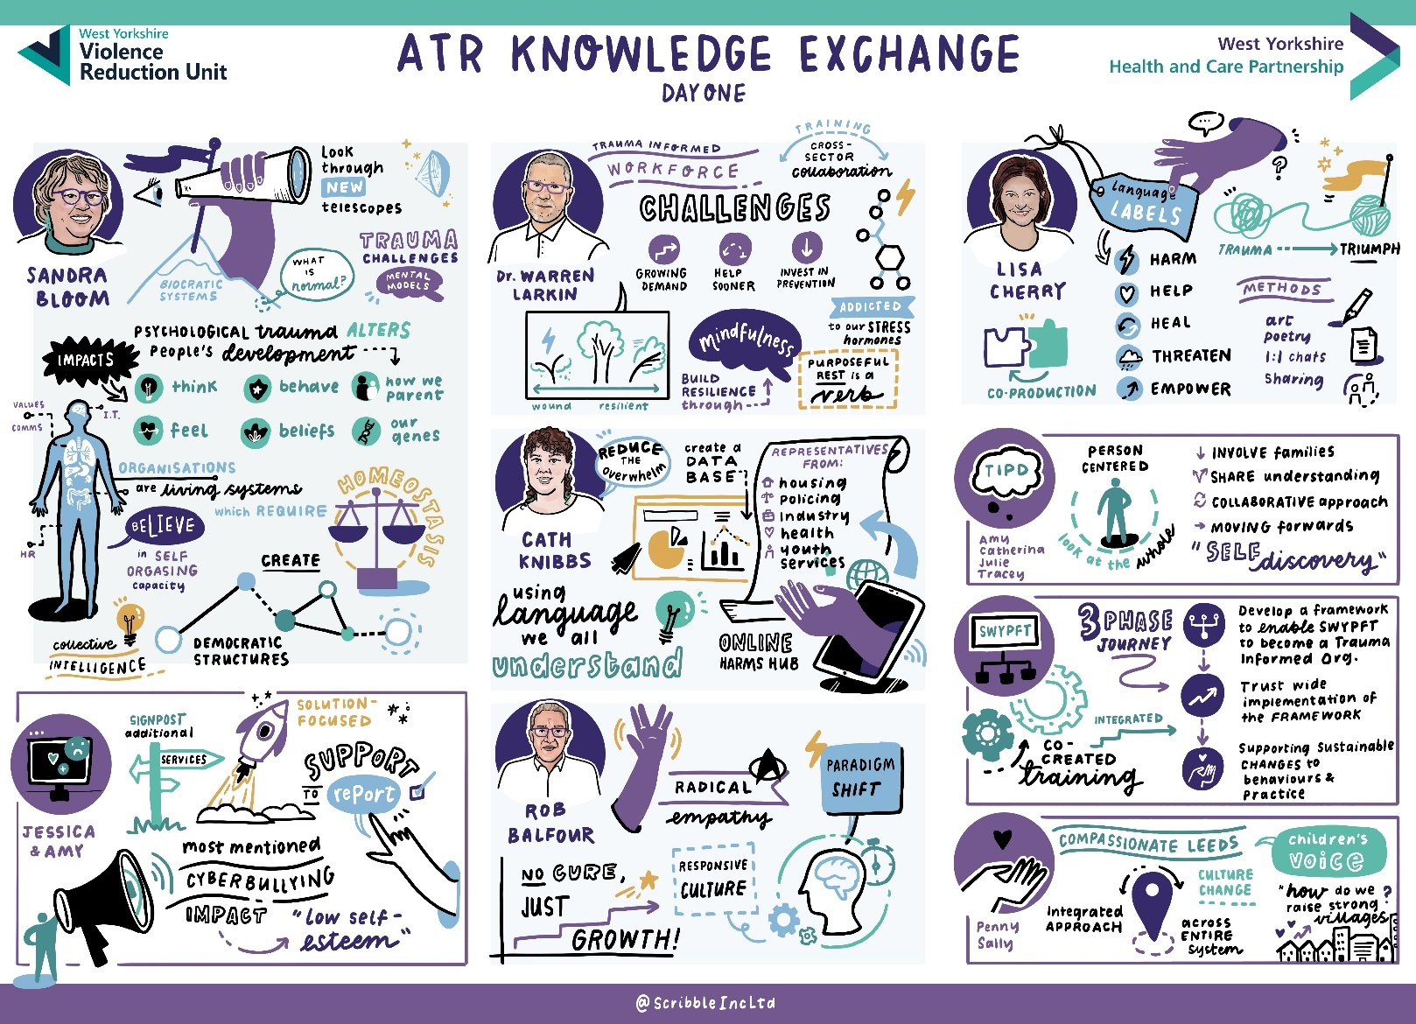

ILLUSTRATIONS FROM DAY 2

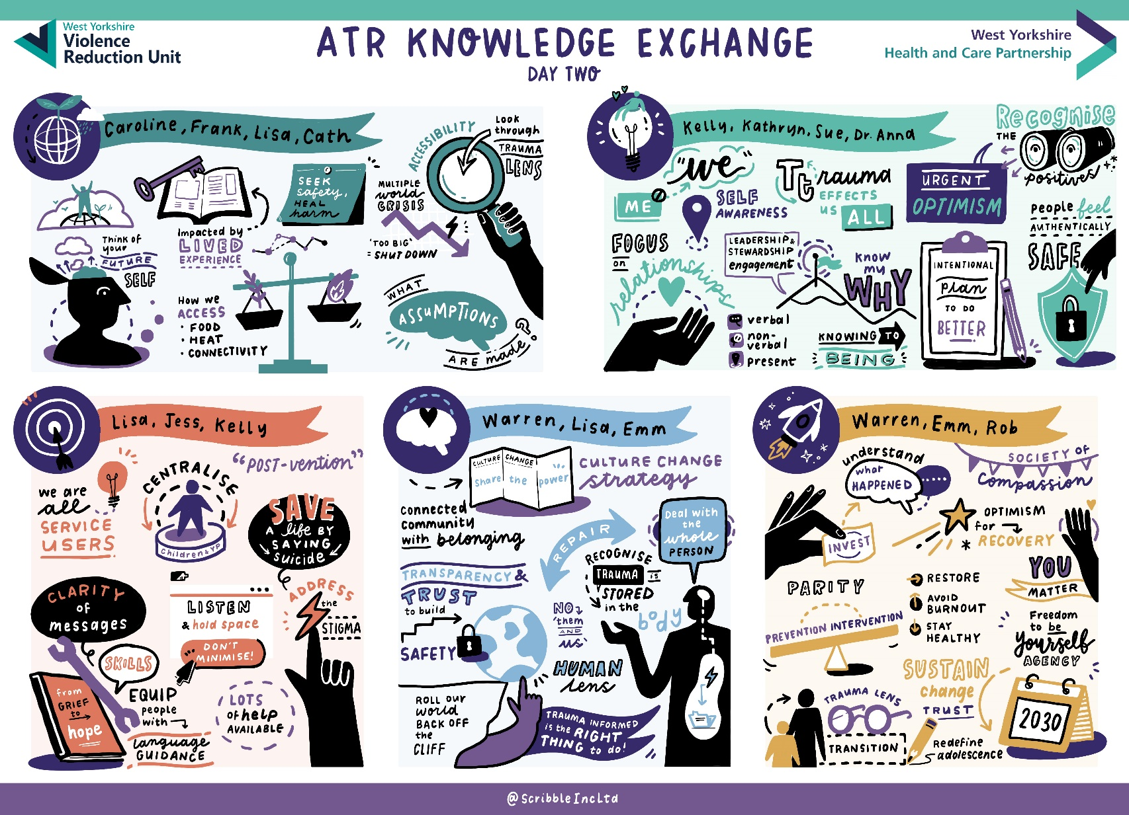

ILLUSTRATIONS FROM DAY 3

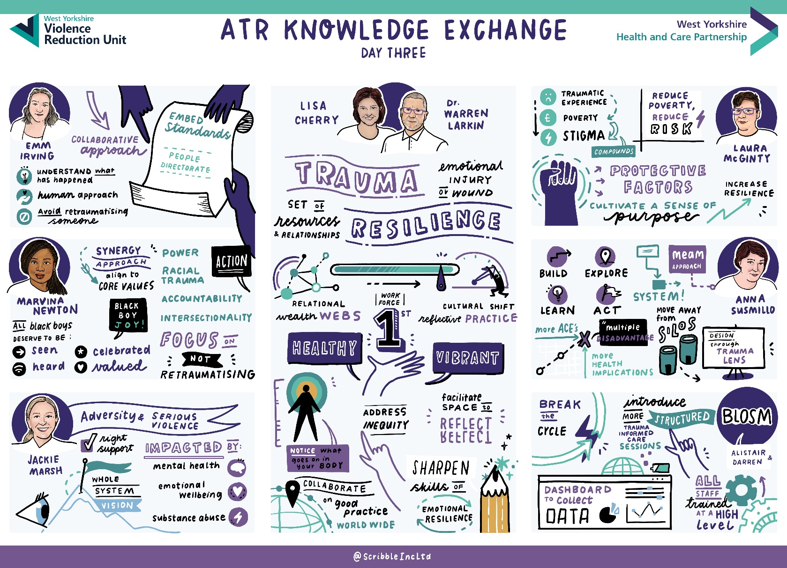

See the event website for the full line up and more information about the speakers. To view all the
recordings from the event, click on the agenda tab and select which recording you want to see. You
can also sign up to our digital hub, which brings together resources to support trauma informed
health and care.
Thank you to everyone involved in the event and we hope to see you again next year.

Embedding Trauma and Resilience

Inside Government hosted an event on 28 March to explore work on embedding trauma and resilience programmes across the public sector this week. Emm Irving, Senior Programme Manager for Improving Population Health, chaired the virtual event and also led a session around creating a regional approach to delivering trauma-informed services.

Workstream Updates:
Please note that all meetings will be recorded and only an action log will be produced. The recordings are only available for the members of the meeting and if you would like a copy, please let Caroline Andrews know.

WY ATR Steering Group
The focus for this group in March was:
- Programme updates (see below for each workstream).
- ATR Fellows have now begun their public health training and have been introduced to their mentors. Updates will be provided through this group.
- Education Awareness Week - this was well attended by colleagues across the network and the content can be accessed through the digital hub,
- Trauma Informed Co-production Training – this took place live on 25 January and was recorded. This will be added to our website in the next couple of weeks as an e-learning resource.
- Trauma Informed E-Safety Training – this took place live on 29 March and was recorded. This will also be added to our website in the next couple of weeks as an e-learning resource.
- We discussed the occurrence of these meetings, and it was agreed that they would now take place quarterly. The next meeting will take place on Thursday 8 June. If you still have an invite from Emmerline Irving in your diary, please can you remove and replace it with the invite sent from Caroline Andrews. If you would like to join this network please contact caroline.andrews16@nhs.net.

WY ATR Community Action Collective
The next meeting will be held on Tuesday 11 July and the focus will be the trauma informed
co-production language document produced by Lisa Cherry.

WY ATR Trauma Informed Education
These meetings have not taken place since January due to events and school holidays. The next meeting will take place on Friday 19 May. This meeting will focus on online harms with a presentation from Cath Knibbs.

WY ATR Criminal Justice Workstream
The focus at the meeting held in January was:
- Kerry Hinsby provided a presentation in respect of Provider Collaborative. If you would like a copy of the presentation, please contact Caroline Andrews.
- There was a discussion around a face to face workshop being held in March and Kelly Laycock from the Violence Reduction Unit offered to fund this event. Further details to follow.

WY ATR Social Media and Cyber Trauma
The focus at the meeting held in March was the development of a West Yorkshire Online Harms Policy and the group discussed ideas of what to include.

Reducing Violence Against Staff
- At the last meeting we invited Dr Warren Larkin to provide the Trauma Informed Foundation Training to members of this group. Unfortunately, not all members were present but the feedback received to date has been very positive. The next meeting is being held on 2 May where we will discuss the training, colleagues will provide feedback and will then consider priority areas within their Trust.
- At the next meeting we will also be discussing the benchmarking which is a requirement of NHSE for this pilot.

Trauma of Racism
This workstream will be launching very soon and expressions of interest will be sent to all colleagues.

If you would like any further information on the workstreams please refer to the West Yorkshire ATR Academy Hub https://westyorkshiretraumainformed.co.uk/ or contact caroline.andrews16@nhs.net

Improving Population Health ATR Fellows
The ATR Fellows have begun their public health level 1 training and have been linked to their mentors. Most mentors and fellows have now had their first meeting and will be beginning their project. We will provide further updates at the quarterly Steering Group and in the bulletin.

Youth Endowment Funding
The YEF have announced funding round 'A supportive home' to test how partnerships between local public services and community organisations can protect children and young people from violence and exploitation outside the home (extra-familial harm).

Applications must be led and submitted by the local authority.

Partnerships must include:
Local authority – inclusive of early help; children’s social care; Youth Offending Team; education; youth work (where delivered by the local authority); relevant services to support young adults.
Voluntary, Community, Faith and Social Enterprise (VCFSE) delivery partners – these may be large specialist organisations and/or local specialist grassroot organisations who are known and trusted by the communities.
The police.
Probation services.
Mental health professionals for both children and young adults.
Education, (if not part of the local authority) including schools.

Please use this link for further information Agency Collaboration Fund: A supportive home - Youth Endowment Fund

The Champions of Childhood Conference, Leeds Trinity University, Thursday 25 May 2023 (free of charge)

The Champions of Childhood conference is hosted by the School of Children, Young People and Families at Leeds Trinity University.
This is an opportunity to engage with current research and knowledge exchange across our multidisciplinary sector. Key speakers will share current practices when working with children, young people or families across the public, private and voluntary sector examining a range of current challenges and innovative ways forward.

The conference will explore childhood across the age ranges, from early years to teenage years, and the wide range of professional roles that exist across this dynamic professional remit. This will include opportunities to network with others who share the ambition to improve all aspects of childhood.

Who should attend?
Current students; Practitioners and managers from across Children’s services including education, early years and family support teams; Mentors; Employers, Alumni; future students.

Key Speakers include:
Richard Driffield - Chief Executive Officer The Joshua Tree - The Joshua Tree provides a bespoke programme of support to improve the emotional well-being and mental health of all immediate and extended family members who are affected by childhood cancers, across North-West England and North Wales, for as long as they need it.

Andy Simpson and Leonie Taylor - Brightsparks Agency and Community Interest Company is a social purpose and creative agency based in Yorkshire that works across the UK and Europe using behaviour change methodologies and digital solutions to deliver improvements to children's health and social care systems.

Emmerline Irving - West Yorkshire Health and Care Partnership is the Head of Improving Population Health. This role includes leading on prevention across the partnership including, maternity, reducing serious violence to improve outcomes and reducing health inequalities for the population across West Yorkshire.

Saira Mirza – Family Worker and PHD student - Empowering Women of a South Asian Background

Katy Collins – Experiences working as a High intensity CBT therapist

Also in attendance sharing reflections on their work are:
Best Childcare Forest School Nursery,
Zarach, Leeds
Anna Freud Centre

The University is hoping to get local organisations involved for networking with their students that have just graduated, looking for jobs, ideas for career progression etc.

It is free admission and the day includes refreshments and lunch, please book to attend using this link Champions of Childhood Conference Tickets, Thu 25 May 2023 at 09:30 | Eventbrite and we look forward to seeing you.

